2017 Miami to Key Largo Race
April 22, 2017
SAILING INSTRUCTIONS
- RULES
  - The Race will be governed by the current Racing Rules of Sailing as adopted by the US Sailing Association, PHRF rules and regulations, and any class rules except as amended by the Sailing Instructions.
  - Class rules requiring membership in a class association shall not apply
  - The requirements of RRS, Appendix G, ISAF marking on sails, shall not apply.
  - There are no PHRF crew restrictions on number or weight of crew.
- NOTICE TO COMPETITORS
  - Notices to competitors will be posted on the official notice board located outside the meeting room of the Miami Yacht Club.
- CHANGES TO SAILING INSTRUCTIONS
  - Any change to the sailing instructions will be in writing and posted by 9:00PM April 21, 2017, on the official Notice Board at the Miami Yacht Club and Miami-Key Largo page on YachtScoring.com.
- SIGNALS MADE ASHORE
  - There shall be no signals made ashore.
- SCHEDULE OF RACES
  - This race shall consist of one race with one start, scheduled for Saturday, April 22, 2017. The warning signal shall be made at 7:55AM.
- CLASS FLAGS/MIAMI-KEY LARGO RACE FLAGS
  - There shall be no class flags. MYC burgee will be used as the class/start flag.
  - The Miami-Key Largo Race flag must be flown from a starboard shroud during the entire race. If a boat has no shrouds, the race flag must be attached from the back leech area of the aft most sail.
- COURSE
  - The race shall start approximately ½ mile south of the Rickenbacker Causeway Bridge. The race shall end near the North end of Jewfish Creek.
  - Boats are permitted to use engine propulsion in the marked channels of Featherbed Bank, Cutter Bank, Card Bank and Barnes Point Channel. The engine and propulsion must be turned on and engaged at 2 boat lengths to the nearest (port or starboard) northern most day marker of each channel. (See addendum 1) All boats honoring the government day markers for these channels shall not pass, under propulsion or under sail. Safe passage through the channels is priority #1.
- MARKS
  - There is no requirement to honor any marks of any kind, other than at the start and at the finish. Several areas on the course are extremely shallow and impassable by keelboats. Each skipper is responsible for finding water deep enough for his/her boat. Do not damage environmentally sensitive areas in the Biscayne National Park.
- THE START
  - The RC Start Boat will be displaying a large blue RC flag.
  - All Multi-hulls will start between the West orange mark and an orange flag on the West side of the RC Start Boat. All mono-hulls will start between the East orange mark and an orange flag on the East side of the RC Start boat. The starting sequence is:
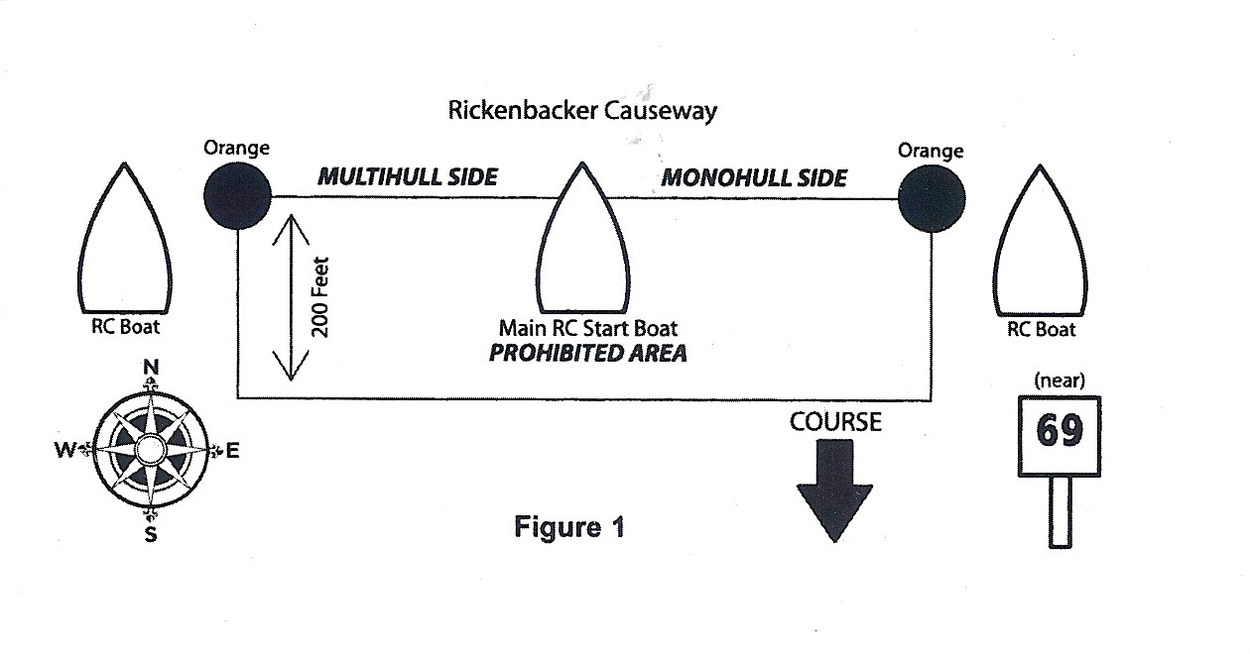
Minutes before start flag:
Five MYC burgee Raised
Four “P” blue with white square Raised
One “P” Lowered
Start MYC burgee Lowered
  - The Race Committee will make an attempt to make a radio announcement at ten and five minutes before the starting sequence begins. Failure to make the announcement will not be grounds for redress. The Race Committee will use VHF channel 72.
  - Although rare, postponements will be signaled by repeated sound blasts and a postponement (AP) flag. This changes RRS rule 27.3
  - The race committee will make a reasonable attempt to identify On Course Side boats. OCS boats shall be any boat on the course side (SOUTH) of the starting line(s). Any boat identified as OCS (South of the Starting Line(s)) within five minutes before the start (i.e., after the warning signal) shall receive, without a hearing, a thirty minute penalty added to her uncorrected finish time. This changes RRS 29.1 and 30, A-3, and A-5.
  - Boats starting later than twenty (20) minutes after their starting signal will be scored Did Not Start (DNS) without a hearing. This changes RRS.35
10 THE FINISH
10.1 All boats shall finish near the North end of Jewfish Creek. The finish line shall be between an orange flag
on the RC Finish Boat (to starboard) and a yellow mark (to port). The RC Finish Boat will be displaying a large blue RC Flag.
10.2 Each boat will be assigned a unique number, which is included in the registration package. The number must be displayed continuously to the RC Finish Boat as the boat finished until it clears the finish area.
- Time Limit
11.1The Race Committee will stop taking finishes at 6:00 PM.
- Protests and Requests for Redress
  - Protest forms are available at http://raceadmin.ussailing.org/Assets/Race+Admin/Racing+Rules/2013-2016+RRS/2013-2016_protest_form.pdf and also available at Miami Yacht Club.
  - Protest forms must be submitted to Miami Yacht Club, Miami Yacht Club Officer, Racecommitteemyc@gmail.com, before 6:30PM, April 25, 2017.
  - The names and numbers of boats and parties involved in all protests will be posted on Official Race Notification Board at the Miami Yacht Club and Yacht Scoring.com by 7:00 PM, Tuesday, April 25, 2017.
  - Protest hearings will begin at 7:00PM, Wednesday, April 26, 2017.
  - Redress will not be granted for damaged or missing government markers.
  - No redress will be granted regarding wind velocity recording for ORC. The final wind bearing and velocity will take place aboard the RC Committee Boat at 07:45:00 and then entered for the record.
- SCORING
  - An entry sheet shall be distributed at the Skipper’s meeting. It will identify the scoring system that will be used for each class.
  - Scoring for classes completing the full course, using a handicapped-scoring system will be based upon a distance of 35 nautical miles.
  - Ties will be broken in favor of the person who is older by chronological age of the tied registered skippers. This modifies RRS Rule A7.
- SAFETY REGULATIONS
  - A boat that retires from the race shall notify the race committee as soon as possible. Please use VHF Channel 72 or call 305-310-5774.
  - All boats must carry a tow line at least 20’ long.
  - All non-cruising catamaran sailors must wear PFDs while racing. This modifies RRS rule 40.
  - All boats must have one person 18 years or older or be accompanied by a safety boat that has a person 18 years or older.
  - Each skipper is responsible for the safety and security of his/her crew. All boats must carry all equipment required by law and by the provisions of these Sailing Instructions.
- ADVERTISING
  - Advertising will be restricted to ISAF Regulation 20.
- CANCELLANTION
  - Short of a hurricane or extremely bad weather, the race will not be cancelled or abandoned.
  - The race will not be rescheduled.

Addendum 1

The Miami Yacht Club as the Organizing authority for annual Miami Key-Largo Race will cannot recommend that any vessel, regardless of size, not honor all relevant government day markers.

The northern most day markers for the channels outlined in 7.2 are listed below. It is up to the individual skippers to obtain current approved navigational reference tools, charts or chart plotters, to verify day marker positions.

Markers may be missing or damaged, please refer to Current Notice to Mariners provided by USCG.

Featherbed Bank: northernmost day markers are “3” and “4”. Southern most are “5” and “6”.

Cutter Bank: northernmost day markers are “8a” and “9”. Southernmost are “14” and “15”

Card Bank: northernmost day markers are “16” and “17”. Southernmost are “20” and “21”

Barnes Point Channel (under card sound bridge): northernmost day marker is “22”. Southernmost are “26 and “27”

